Probability Unit
Grades 9 -12

Robert Berg, Saint Paul Public Schools; robert.berg@spps.org
Kevin Brenner, Cloquet Senior High School; kbrenner@isd94.org
Bill Garnett, Duluth East Senior High School; william.garnett@isd709.org

Executive Summary

The Minnesota State Math Standards that are addressed in this unit are as follows:

Standards:
NCTM standard D4: Understand and apply basic concepts of probability.
- Understand the concepts of sample space and probability distribution and construct sample spaces and distributions in simple cases.
- Use simulations to construct empirical probability distributions.
- Compute and interpret the expected value of random variables in simple cases.
- Understand the concepts of conditional probability and independent events.
- Understand how to compute the probability of a compound event.
NCTM standard D3: Develop and evaluate inferences and predictions that are based on data.
- Use simulations to explore the variability of sample statistics from a known population and to construct sampling distributions.
- Understand how sample statistics reflect the values of population parameters and use sampling distributions as the basis for informal inference.
NCTM standard G4: Use visualization, spatial reasoning, and geometric modeling to solve problems.
- Use geometric models to gain insights into, and answer questions in, other areas of mathematics.
- Use geometric ideas to solve problems in, and gain insights into, other disciplines and other areas of interest such as art and architecture.
MN Math Standard 9.4.3.1: Select and apply counting procedures, such as the multiplication and addition principles and tree diagrams, to determine the size of a sample space (the number of possible outcomes) and to calculate probabilities. For example: If one girl and one boy are picked at random from a class with 20 girls and 15 boys, there are 20 × 15 = 300 different possibilities, so the probability that a particular girl is chosen together with a particular boy is 1/300.

MN Math Standard 9.4.3.2: Calculate experimental probabilities by performing simulations or experiments involving a probability model and using relative frequencies of outcomes.

MN Math Standard 9.4.3.3: Understand that the Law of Large Numbers expresses a relationship between the probabilities in a probability model and the experimental probabilities found by performing simulations or experiments involving the model.

MN Math Standard 9.4.3.4: Use random numbers generated by a calculator or a spreadsheet, or taken from a table, to perform probability simulations and to introduce fairness into decision making. For example: If a group of students needs to fairly select one of its members to lead a discussion, they can use a random number to determine the selection.

MN Math Standard 9.4.3.5: Apply probability concepts such as intersections, unions and complements of events, and conditional probability and independence, to calculate probabilities and solve problems. For example: The probability of tossing at least one head when flipping a fair coin three times can be calculated by looking at the complement of this event (flipping three tails in a row).

Learning Opportunities:

Students will be exposed to various activities and models that will require them to design sample experiments and collect data throughout this unit. Students will be asked flip coins, roll dice, use tables of random numbers, use random numbers generators so they can calculate experimental probability. Students will also build sample spaces and use the law of large numbers to find theoretical probability. They will be introduced to the necessary vocabulary that will be used throughout their study of probability.

Sample MCA Questions:

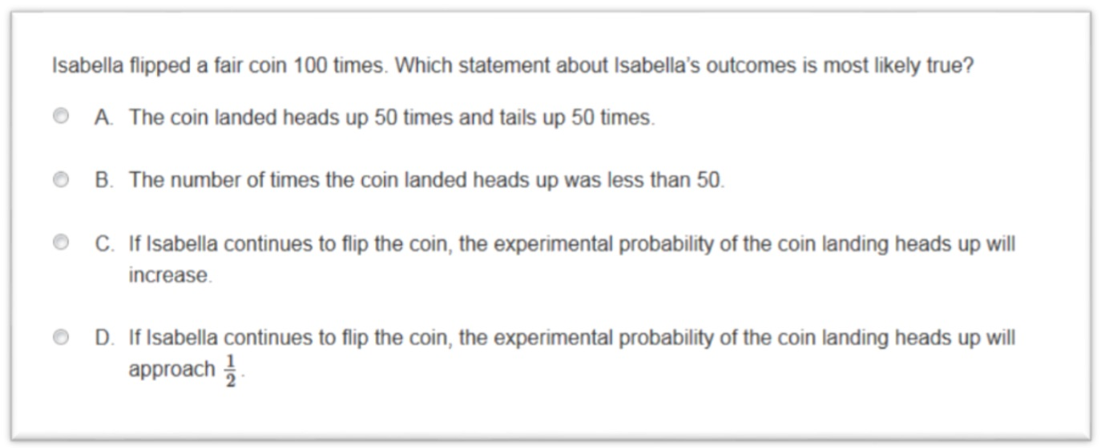

Sample MCA Test Items taken from http://scimathmn.org on 2/26/2017:

Tara plays a game using 2 bags of game pieces. One bag has 6 blue game pieces and 6 red game pieces. The other bag has ten game pieces numbered 1 through 10. On her turn, Tara must draw one game piece from each bag. What is the probability that she draws a red game piece and an even-numbered game piece?

Jeremy plays soccer. He scores a goal in 40% of his games. Jeremy want to design a simulation using a spinner to predict the probability that he will score a goal in 8 out of 10 games. Which simulation design has an appropriate device and a correct trial?

Table of Contents

Day 1: Flip - Spin – Bang……………………………………….. Page 6
Day 2: Marshmallow Madness……………………………... Page 9
Day 3: Die, Dice, and 6………………………………………….. Page 12
Day 4: Simulated Sum…………………………………………… Page 15
Day 5: Rolling Three……………………………………………… Page 17
Day 6: Treasure Stashing………………………….…………… Page 20
Day 7: The Money Grab………………………………………… Page 23
Day 8: China One Child Policy……………………………….. Page 26
Day 9: Daddy Wants a Son……………………………………. Page 27
Day 10: World Series……………………………………………. Page 28
Day 11: Didn’t Study…………………………………………….. Page 29
Day 12: Cereal Box Problem…………………………………. Page 30
Day 13: Voting for Class President……………………….. Page 31
Day 14: The Price is Right…………………………………….. Page 33
Day 15: Understanding Probability………………………. Page 36
Day 16: Telephone Numbers……………………………….. Page 43
Day 17: Find the Odds…………………………………………. Page 45
Pre Test……………………………………………………………….. Page 47
Post Test……………………………………………………………… Page 48

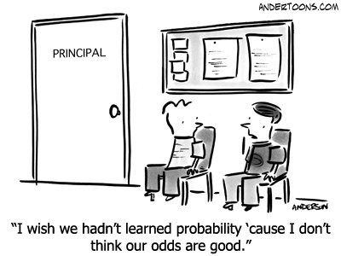

Introduction to Probability: For students in the regular track or below in grades 9 or 10

Standards:
NCTM standard D4: Understand and apply basic concepts of probability.
- Understand the concepts of sample space and probability distribution and construct sample spaces and distributions in simple cases.
- Use simulations to construct empirical probability distributions.
- Compute and interpret the expected value of random variables in simple cases.
- Understand the concepts of conditional probability and independent events.
- Understand how to compute the probability of a compound event.
NCTM standard D3: Develop and evaluate inferences and predictions that are based on data.
- Use simulations to explore the variability of sample statistics from a known population and to construct sampling distributions.
- Understand how sample statistics reflect the values of population parameters and use sampling distributions as the basis for informal inference.
NCTM standard G4: Use visualization, spatial reasoning, and geometric modeling to solve problems.
- Use geometric models to gain insights into, and answer questions in, other areas of mathematics.
- Use geometric ideas to solve problems in, and gain insights into, other disciplines and other areas of interest such as art and architecture.
MN Math Standard 9.4.3.1: Select and apply counting procedures, such as the multiplication and addition principles and tree diagrams, to determine the size of a sample space (the number of possible outcomes) and to calculate probabilities. For example: If one girl and one boy are picked at random from a class with 20 girls and 15 boys, there are 20 × 15 = 300 different possibilities, so the probability that a particular girl is chosen together with a particular boy is 1/300.

MN Math Standard 9.4.3.2: Calculate experimental probabilities by performing simulations or experiments involving a probability model and using relative frequencies of outcomes.

MN Math Standard 9.4.3.3: Understand that the Law of Large Numbers expresses a relationship between the probabilities in a probability model and the experimental probabilities found by performing simulations or experiments involving the model.

MN Math Standard 9.4.3.4: Use random numbers generated by a calculator or a spreadsheet, or taken from a table, to perform probability simulations and to introduce fairness into decision making. For example: If a group of students needs to fairly select one of its members to lead a discussion, they can use a random number to determine the selection.

MN Math Standard 9.4.3.5: Apply probability concepts such as intersections, unions and complements of events, and conditional probability and independence, to calculate probabilities and solve problems. For example: The probability of tossing at least one head when flipping a fair coin three times can be calculated by looking at the complement of this event (flipping three tails in a row).
Day 1

Lesson 1: Flip-Spin-Bang

Objectives: Students will find personal and experimental probabilities. They will define a probability distribution and the law of large numbers. They will use the law of large numbers to understand streaks.

Launch: There is a family with 2 children (mine)! The children have jobs (like most families) and washing the dishes after supper is the least favorite. The oldest child wants to use a coin each night to make deciding who does the dishes more interesting. However, he wants to know if how you use the coin matters.
Explore: Break students into groups of 3-4 students. Each group of students gets a coin. The groups flip the coin 10 times and counts the number of times heads occurs. Then, they spin the coin 10 times and record the heads. Finally, they balance and bang their hand near the coin and record 10 trials. Before doing the experiments, groups should decide what the probability of heads will be for each method.

Share: After completing the trials, the groups share their results for each. They are to discuss is the methods are all equally likely or fair. The teacher should make sure they understand equally likely and fair. Next the teacher adds all the trials together into a large sample. Students should then consider if the different methods are fair.

Summarize:
- The teacher defines personal, experimental, theoretical probability, simulation, and probability distribution. Then the teacher defines the law of large numbers: as sample size increases, the experimental probability approaches the theoretical probability. Apply LLN to all 3 methods.
- Now explore streaks. Have each group look at flipping and find the first time they got two heads in a row. Make a chart recording the next flips outcome by putting all the groups together. Add to the chart by collecting the data from spinning and banging. Note this should be close to the theoretical probability. Have students notice that the streak does not effect the probability. Streaks are expected but each outcome is independent.
Assignment: Students are to complete the activity page items to practice and demonstrate if they understand today’s probability concepts.

Probability and Statistics: Flip-Spin-Bang Worksheet Name:___________________
- What do you believe will happen in 10 trials when you flip a coin? What if you spin it? What if you balance it and bang your hand near it to flip it over?

2) Record your data here:
Trial | 1 | 2 | 3 | 4 | 5 | 6 | 7 | 8 | 9 | 10 | Total H’s
Flip
Spin
Bang

3) Share your results with the class. What does it mean to be fair? Are all three methods fair?

4) Pool all the sample together in the table below. How can this table help you?
Method | Flipping | Spinning | Banging
Total Heads
Percent

5) What is personal probability?
6) What is experimental probability?
7) What is theoretical probability?
8) What is simulation?
9) What is the law of large numbers?
10) How can we use the law of large numbers to learn about different ways to use a coin. How can this help us if we are flipping a coin for a job?

11) To examine streaks, let’s look at what happened right after the first time we got heads two times in a row.
 | Tally | Total | Percent
Heads
Tails

12) Are streaks common or unusual?

13) What is the probability of getting the next head while on a streak?
Part 2: A student makes a free throw about 80% of the time.
14) What is the probability of making the next free throw? Why?

15) Is it likely or unlikely that she will make several in a row. Explain.

15) What if she hits 5 in a row? What is the probability she makes the next one?

16) Which of the following is more likely: making 1 out of 10 or making 10 out of 100? Why?

17) Assume she is in a free throw shooting contest and gets to take 100 shots. If she only makes 1 of her first 20 shots, how many should we expect her to make out of all 100 tries?

18) Can you create a simulation to represent the basketball players free throw shooting?

19) Why might we want a simulation for an experiment?

Day 2

Lesson 2: Marshmallow Madness

Objective: Students will use experimental probabilities to predict theoretical probabilities using the law of large numbers. Students will graph cumulative probabilities to estimate theoretical probabilities. Students will use probability to choose a preferred method for selecting an outcome in a potential real-life event. Students will experience probabilities with 2 outcomes that are not equal.

Launch: The kids are at it again! They are tired of taking turns picking up the yard (sticks, garbage, dog logs etc.). So, they want to make a game (and perhaps take advantage). They are going to flip a quarter, a large marshmallow, or a small marshmallow to see if there is a way to make or rig the jobs.

Explore: Arrange students into groups of 3-4.
1) Notice how the coin and both marshmallow have only 2 outcomes. Do you think the outcomes will be equally likely?
2) Complete the tables for the trials for all 3 experiments use H/T for coin and S/E for marshmallows.
3) Complete the cumulative frequency row for each trial and make a cumulative relative frequency vs trials graph for each method. Use a different color for each method.
4) Find a method and estimate the theoretical probability for Heads or Ends for each experiment. Are the methods fair? Use this information to determine a way to select which sibling does the job.

Share: Groups share the conclusions and arguments on the board.

Summarize:
1)The teacher collects all the samples and groups them together to make a large sample. Review: probability distribution, personal, experimental and theoretical probability. Students apply the law of large numbers to verify or change their conclusions. Make sure students see the law of large numbers showing up as trials accumulate on the CRF vs trials graph.
2) Collect data from the class to explore what occurs after 2 ends have occurred on the small marshmallows. Review independence.

Assignment: Students are to complete the activity page items to practice and demonstrate if they understand today’s probability concepts.

Probability and Statistics: Marshmallow Matters Worksheet Name:__________________

1) Are all experiments with 2 outcomes equal? Flipping the coins and marshmallows are experiments with 2 outcomes. Do you expect the outcomes will be equally likely for all these outcomes? Explain why or why not.

2) Record your data here: H/T = outcome, CH is cumulative # of heads, C%H is cumulative relative frequency for heads. L is large marshmallow, S is small. E/S is end or side.
Trial | 1 | 2 | 3 | 4 | 5 | 6 | 7 | 8 | 9 | 10 | 11 | 12 | 13 | 14 | 15 | 16 | 17 | 18 | 19 | 20 | Total
H/T
CH
C%H
LE/S
CE
C%E
SE/S
CE
C%E

3) Make your 3 graphs of Cumulative relative frequency vs trial number here. Use colors and label.
 | 1
 | 0.9
 | 0.8
 | 0.7
 | 0.6
CRF | 0.5
 | 0.4
 | 0.3
 | 0.2
 | 0.1
 | 0
 |  | 1 | 2 | 3 | 4 | 5 | 6 | 7 | 8 | 9 | 10 | 11 | 12 | 13 | 14 | 15 | 16 | 17 | 18 | 19 | 20
 |  |  |  |  |  |  |  |  |  |  | Trial Number

4) Find a method and estimate the theoretical probability for Heads or Ends for each experiment. Are the methods fair? Use this information to determine a way to select which sibling does the job.

5) Pool all the sample together in the table below.
Method | Flipping Coin | Large Mallow | Small Mallow
Total Heads or Ends
Percent

6) Does this table support or refute your estimates for the theoretical probability. How does it do this?

7) How are experimental and theoretical probability different?

8) What is the best method for you to use if you must play a game with a sibling for an unwanted job?

9) To examine streaks, let’s look at what happened right after the first time we got ends two times in a row on the small marshmallow
 | Tally | Total | Percent
Ends
Sides

10) How does the probability of a 3rd end compare the theoretical probability of getting ends?

Part 2: A student claims a Hershey’s Kiss lands on its base 30% of the time.
14) What is the probability of it landing on its side? Why?

15) Is it likely or unlikely that it will land side base side… and continue to alternate?

15) What if it lands on its base 6 times in a row? What is the probability it lands on its base next time?

16) Which of the following is more likely: landing 4 out of 5 times or landing160 out of 200 times on the base? Why?

17) Assume you are going to toss a Kiss 50 times. If only 1 of the first 20 lands on its base, how many times should we expect it to land on its base over the entire 50 tries?

Day 3

Lesson 3: Die, Dice, and 6

Objective: Students will find experimental and theoretical probabilities while rolling 1 or 2 dice. Students will use the law of large numbers to estimate theoretical probability. Student will use sample spaces (lists, Punnet tables, and trees) to determine theoretical probabilities. Students will define and find complements.

Launch: Your best pal is at your house and you are playing Sorry (a game with 1 die). Winner gets to pick what movie you watch and your friend’s taste in movies is rather boring. It’s your turn and to win all you have to do is roll a 6.

Explore: Students are in groups of 3-4. Provide them with two dice.
1) Each student records their personal probability of rolling a 6. The groups share their probabilities and reasoning with each other.
2) Each member of the groups rolls a die 20 times and counts how many times each outcome occurs. Compare this to your personal probabilities. Does equally likely mean equally occurring? Pool your results and discuss the law of large numbers
3) See if you can construct a sample space for the probability distribution and find the theoretical probability.
Share: Students post their rolls, team totals, sample spaces, and theoretical probability on the boards.
Summarize: Teacher demonstrates sample spaces: lists and trees for the problem and uses these to find theoretical probability to compare with law of large numbers for entire class size. Discuss what equally likely can look like in different size samples and why this happens (LL#”s). Teacher should define complement and find the complements to rolling a 6 or an even or a prime.

Launch: Time for another game (Monopoly?) and this time there are two dice. If you need to roll a sum of 6 to win…

Explore:
1) Each student records their personal probability of rolling a sum of 6. The groups share their probabilities and reasoning with each other.
2) Each group rolls 2 dice 20 times and counts how many times each sum occurs. Compare this to your personal probabilities. Are the sums equally likely? Why?
3) See if you can construct a sample space for the probability distribution and find the theoretical probability.

Share: Students post their rolls, sample spaces, and theoretical probability on the boards.
Summarize: The teacher checks groups work, clears any misconceptions, and combines all the rolls into a large sample. What can students conclude from the pooled data? Make sure students have examples of lists, trees, and Punnet square sample spaces. Ask them to find the complement to rolling a 6, or a number less than 5.
Assignment: Students are to complete the activity page items.
Probability and Statistics: Die, Dice, and 6 Worksheet Name:___________________

1) What is your personal probability of rolling a 6? Why?

2) Record your data for 1 die here:
 | 1 | 2 | 3 | 4 | 5 | 6
Your #
Your %
Group #
Group %
Class #
Class %

3) What does the law of large numbers tell us about rolling 1 die? Does equally likely mean they must occur equal times?

4) Construct a sample space for rolling 1 die and use it to determine P(6).

5) Record your data for 2 dice here:
 | 2 | 3 | 4 | 5 | 6 | 7 | 8 | 9 | 10 | 11 | 12
Group #
Group %
Class #
Class %

6) What does the law of large numbers tell us about rolling 2 dice? Are the outcomes equally likely? Why?

7) Construct a sample space for rolling 2 dice and use it to determine P(sum 6).

8) Find P′(6)

9) To save time, describe a way to simulate rolling to dice to make a large sample.

Part 2
When playing a super fun game in math class a student has to select one object from each of 2 carefully mixed bags. Bag 1 contains 1 red, 1 blue, and 1 yellow marble. Bag 2 contains tiles with the numbered 1-4.
10) Make a list of all possible outcomes.

11) Make a tree diagram of all possible outcomes.

12) Make a Punnet square of the possible outcomes.

Use your sample spaces to determine the following:
13) Find P(red and 2) 14) Find P(any red) 15) Find P(red or 3)

16) Find P′ (red and 2) 17) Find P′ (red) 18) Find P(3 if it must be red)

Part 3: Let’s take a look at whether the children in a family are boys or girls. Construct a sample space for each of the following families using b for boy and g for girl. You may assume that having a baby boy or girl is equally likely.
19) The family has 2 children

20) 2 children, at least 1 is a boy

21) 2 children, the oldest is a boy

22) What is P(2), the probability of 2 boys, for each family above.

23) Are the probabilities equally likely? Which family has the highest probability of having 2 boys? Why?

24) What is P′ (2boys) for the family in problem 19?

Day 4

Lesson 4: Simulated Sum

Objective: Students will design simulations to find probabilities.

Launch: Monopoly again! And you still need a sum of 6 to win. Let’s try a few rounds on the smartboard instead of rolling dice. Have several students play on the board until they win. Combine their results for a crude estimate of P(sum 6).

Explore: Allow groups of students to try to design a way to simulate rolling 2 die for a sum. They should try their simulation to see if they believe it is working.

Share: Each group presents their simulations and results.

Summarize:
1) The teacher should summarize the qualities and values of a good simulation. Make sure typical simulations are present: spinners, coins (how?), cards, technology, papers in hats, etc.
2) The teacher should demonstrate a technology method. One method is to put 100 random digits 1-6 in list 1 and 2 on the TI calculator. Place their sum in L3. Make a histogram or count the number of 6’s in L3. A class total can be found for a better approximation.

Assignment: Students are to complete the Simulations Worksheet.

Probability: Simulations Worksheet Name:___________________
Simulations may require protractors, rulers, or technology to be completed.
1) A probability student typically gets an A about 80% of the time on quizzes. Design a spinner to use as a simulation for this student’s test scores. Draw your spinner here:

2) Use your spinner estimate how many times the student could get an A out of 10 quizzes.
Trial | # of A’s | % of A’s
1
2
3
4

3) Do your simulations appear to fit the student’s probability? Explain?

4) Explain how you would use a deck of cards to simulate this problem?

5) Explain how you would use dice to simulate this problem?

6) Is there a way to use coins? Explain.

7) How could you use the TI?

8) Your favorite breakfast cereal has four different awesome prizes possible in any box! The prizes are equally likely. Describe and design a simulation for determine the probability you get each of the four different prizes in your first 4 tries. Try your simulation at least 10 times.

9) Based on your simulations and at least one classmate, what do you believe is the probability of getting all 4 prizes in your first four boxes.
Day 5

Lesson 5: Rolling 3

Objective: Students will find experimental and theoretical probabilities while rolling 3 dice. They will make sample spaces of problems with 3 parts. They will use their knowledge of probability to make decisions in a game. Students will also explore probability problems that include complements, conditions and sums of probabilities.

Launch: Since one of your friends had so much fun playing Monopoly and working on math at your house, another friend has joined you. Looking for some good times, a game of chance, and some math, you naturally wanted to invent a game for 3 people. Here are the proposed rules: Each person rolls 1 die. Before the roll, you state whether the 3 dice will have 1 of the following 4 conditions: even sum, odd sum, even product, odd product. Every time you win, you get a point (MM, jelly bean, cookie, etc.). The winner gets to choose which lake you are heading to tonight.

Explore: Students roll 3 dice and record the results to estimate probabilities. Can you develop a winning strategy for the game? After some time, the teacher will ask the groups to make sample spaces to determine theoretical probabilities.

Share: Groups share their trials, sample spaces, probabilities and strategies for the game.

Summarize: Make sure the correct sample spaces are on the board and that strategies are consistent. Ask for ways to make the game fair. Also ask about complementary probabilities, “or,” and “and” statements: P′ (odd sum), P(odd sum or even product), P(odd sum and even product), P(odd sum if you have an even product).

Assignment: Students are to complete Rolling 3 Worksheet.

Probability: Rolling 3 Worksheet Name:__________________

1) Use your instincts to predict the following outcomes from rolling 3 dice:

P(even sum)= P(odd sum)= P(even product)= P(odd product)=

2) Record your experiment in the chart below. Do at least 20 trials. The class columns are for later.
 | Tally | Frequency | Relative Freq | Class F | Class RF
Even sum
Odd sum
Even product
Odd product

3) Are the outcomes equally likely? How do you know?

4) Complete the class columns by pooling the data from all groups in the class. Develop a strategy, if possible, for playing the game.

5) Draw a sample space and find the following theoretical probabilities:
P(even sum)=

P(odd sum)=

P(even product)=

P(odd product)=

6) Revise or develop a strategy to win the game based on what you have learned.

7) How do we make the game fair?

8) Find the following probabilities:
P′ (odd sum) P(odd sum or even product) P(odd sum if the product is even)

P(even sum or even product) P(even sum and even product)

Part 2:
Instead of rolling dice, your friends want to play Rock Paper Scissors. You have decided there are 3 outcomes for the game: all three the same, all three different, only 2 the same. Conduct and experiment for 20 trials and record your results below:

9) Record your experiment in the chart below. Do at least 20 trials. The class columns are for later.
 | Tally | Frequency | Relative Freq
All 3 the same
All 3 different
Only 2 the same

10) Are the outcomes equally likely? How do you know?

11) Draw a sample space and find determine the number of different outcomes.

12) Find the following theoretical probabilities:

P(3 same)=

P(3 different)=

P(2 same)=

13) Develop a strategy to win the game based on what you have learned.

14) Find the following probabilities:
P’(3 same) P(3 same or 2 same) P(same if the first person shows rock)

P(3 same and 2 same)

Day 6

Lesson 6: Treasure Stashing

Objective: Students will find sample spaces and probability distributions for problems with unequal events. They will use their knowledge of probability to make decisions. Students will also explore probability problems that include complements, conditions and sums of probabilities.

Launch: The pirates have taken the haul and need to stash it from looters. They want to place their treasure at a location where other people are least likely to go. Study the island and find the least likely area where the treasure will be safest from discovery.

Explore: Students study the map and determine where they believe the treasure is least likely to be found.

Share: Groups share solutions and reasoning.

Summarize: Introduce the abbreviated or weighted tree diagram (note multiplication) and the area model sample spaces. Write, describe, and demonstrate the probability distribution. Ask students to compare and contrast the probability distribution to sample spaces.

Explore: Groups now attempt the basketball problem, #3 on the worksheet.

Share: Groups share solutions and reasoning.

Summarize: The teacher verifies that both models are correctly presented and the probabilities are correct.

Assignment: Students are to complete the Treasure Stash Worksheet.

Probability: Treasure Stash Worksheet Name:__________________________

1) Consider the pirates and all visitor to this island must dock and follow the paths. Which area is least likely to be visited, therefore a better hiding place?
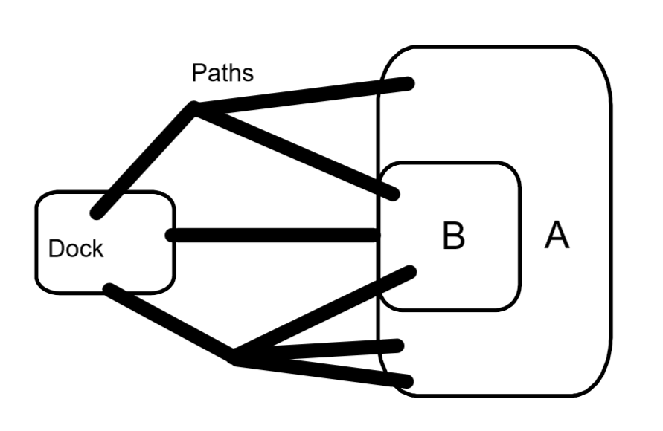
2) Complete this item with your teacher! Pay attention to processes and vocabulary!!

3) A basketball player makes a free throw about 80% of the time. Make a sample space and a probability distribution for all possible outcomes if 2 free throws are to be attempted.

4) Determine:

P(make 2) P(miss 2) P(make 1 miss 1)

P(making at least 1) P(making the 2nd if the first shot missed)

5) Make a sample space and a probability distribution to determine where the treasure is safest.
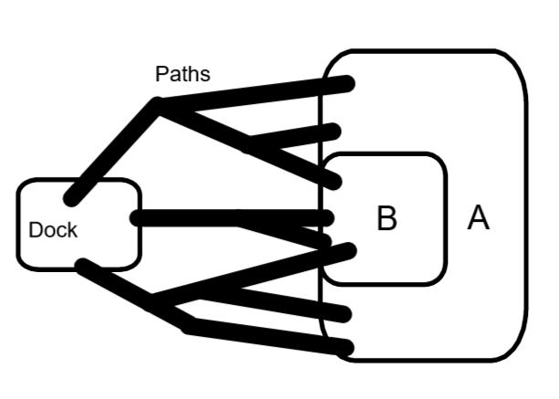

6) A basketball player makes a free throw about 40% of the time. Make a sample space and a probability distribution for all possible outcomes if 2 free throws are to be attempted.

7) Determine:
P(make 2) P(miss 2) P(make 1 miss 1)

P(making at most 1) P(missing the 2nd if the first shot missed)

8) A spinner is divided into three areas. Two are equal and colored red and blue. The third is green equal to the first two combined. Draw the spinner. Make a sample space showing all outcomes for 2 spins. Then, make a probability distribution showing all outcomes.

Day 7

Lesson 7: The Money Grab

Objective: Students will use sample spaces and probability distributions to calculate expected value.

Launch: Congratulations! You’ve been hired by the math department to tutor other students during lunch. You can choose from two payment options: $5 per day or the Money Grab. To do the Money Grab you grab two bills out of a bag. Inside the bag there are one $10 bill and five $1 bills. You should decide which payment method is best!

Explore: Students can do experiments or try to make a sample space to solve the problem.

Share: Groups share solutions and reasoning.

Summarize: See if the students know the method for finding expected value. If not, demonstrate using the MAD (Multiply-Add-Divide) method by examining a probability distribution with values. After this example, determine the solution.

Explore: Groups now attempt the fishing problem, #3 on the worksheet.

Share: Groups share solutions and reasoning.

Summarize: The teacher verifies that sample spaces, models, and expected values are correctly presented and correct.

Assignment: Students are to complete the Money Grab Worksheet.

Probability: The Money Grab Worksheet Name:___________________

1) Congratulations! You’ve been hired by the math department to tutor other students during lunch. You can choose from two payment options: $5 per day or the Money Grab. To do the Money Grab you grab two bills out of a bag. Inside the bag there are one $10 bill and five $1 bills. You should decide which payment method is best! Design an experiment, make a sample space, or use a probability distribution to find the best way to get paid.

2) When Tyler went fishing to Chub Lake he recorded his catches in the table below. What is the expected value for the fish caught on a fishing trip.
Fish | 0 | 2 | 4 | 5 | 7 | 10 | 15
Freq | 1 | 2 | 4 | 4 | 1 | 2 | 4

3) Use the MAD method to calculate the GPA:
Class | Credits | Grade | Value
Math | 4 | A | 4.0
Science | 4 | B | 3.0
Speech | 2 | B | 3.0
Art | 1 | A | 4.0
Phy Ed | 1 | C | 2.0

4) The following table contains the frequency and values for all the outcomes on a slot machine. Find the expected value for 1 play.
Prize | Grand | 1st | 2nd | 3rd | 4th | 5th
Value | $100 | $50 | $20 | $10 | $5 | $0
Freq | 1 | 1 | 2 | 3 | 10 | 162

5) If it costs $2 to play the slot machine in item 4, should you play? Explain.

6) If there is a 45% chance of winning at Blackjack, and you win 4 hands in a row, what is the chance you win the next hand?

7) Are you more likely to win 2 out of 3 or 30 out of 45 hands of Blackjack? Explain.

8) CHS is holding a raffle during parent teacher conference night. One parent will win the grand prize of money. Two parents will win the second-place prize of $100. 500 tickets were sold. The school wants to break even on the lottery. If they sell tickets for $1, how much is the grand prize going to be?

9) At another lottery, the grand prize is worth $20 and the two second place prizes are worth $10. If the expected value of a ticket is $.50, how many tickets were sold?

10) Look back at the Money Grab money problem in problem 1. What is the expected value if you select a bill and it gets replaced with a new bill of the same value before you draw the second time. Does this change your strategy?

11) A spinner is divided into three parts. Part 3 is half of the spinner. Parts 1 and 2 are equal sized. Imagine a game where you spin the spinner twice and multiply the part numbers together to see how much you win. What is the expected value for this spinner game?

Day 8

China One Child Policy

Minnesota Standard 9.4.2- Explain the uses of data and statistical thinking to draw inferences, make predictions and justify conclusions. Design simple experiments and explain the impact of sampling methods, bias and the phrasing of questions asked during data collection.
Launch
In 1979, China introduced a policy that allowed families to only have one child. The result was that the ratio of boys being born to girls was 117 to 100 when the usual rate was 103 to 100. Why might this have been? If we were to flip a coin to simulate the birth of a baby, what would heads represent? What would tails represent? In 2015, China changed the rule to allow for a family to have two children. How could you use coin tosses to simulate the birth of children for this? What is more likely, a boy and a girl or both children the same sex?

Explore
In groups of 3 or 4, conduct 25 trials to simulate the birth of two children. Keep track of:
2 girls
Older girl, younger boy
Older boy, younger girl
2 boys

Share
Collect data from all groups and report results
Ask: How did you design your trial? Did the experimental probability match what you thought would happen. Could we do something to make the simulation better?

Summary
When you flip two coins, there are 4 possible outcomes that are equally likely. The probability of any of the 4 possibilities should be 25%. To make the simulation better you would want to do more trials.

Contemporary Mathematics in Context Course 1 Part B – 1997

Day 9

Daddy Want a Son

Minnesota Standard 9.4.2.3 Explain the uses of data and statistical thinking to draw inferences, make predictions and justify conclusions. Design simple experiments and explain the impact of sampling methods, bias and the phrasing of questions during data collection.

Launch
Suppose a father wanted to have a son to pass on his family name and he and his wife agreed to have children until a boy was born and then stop. How many children do you think a family would have? Would it be possible to design a simulation for this situation? If you repeated the simulation a number of times, what would a graph of the data look like?

Explore
In groups of 3 or 4, design an experiment to simulate a family having children until a boy is born. Keep track of the number of children in a family and the frequency of each family size.
Each group should repeat the experiment 25 to 50 times.

Share
Collect the data from each group.
Answer the following questions:
How many boys were born?
How many girls were born?
How many families had 4 or more children?
What type of graph would be useful in looking at the data? (histogram, frequency table)
What does the graph tell us about this experiment?

Summary
There will be a certain number of families that only have one or two children and there should be some family size that appears to be the average. How would doing more trial affect the results?
Contemporary Mathematics in Context Course 1 Part B 1997

Day 10

World Series

Minnesota Standard 9.4.2.3 Explain the uses of data and statistical thinking to draw inferences, make predictions and justify conclusions. Design simple experiments and explain the impact of sampling methods, bias and the phrasing of questions during data collection.

Launch
The first Word Series in baseball was held in 1903. The two teams played a best of 9 format. Since then, except for 1919 to 1921, the teams have played a best of 7 format. It took the Twins 7 games to win the World Series in 1987 and 1991. If the two teams are equally matched, how many games to you think it will take one team to win?

Explore
In groups of 3 or 4, we will simulate the World Series. First, list the number of games in order that you think it will take to win the series. Ex: 5,6,4,7
Design an experiment to simulate playing the World Series and keep track of how many games were played before a winner was determined.
Each group should repeat the experiment 25 to 50 time

Share
Collect the data from each group.
Answer the following questions:
What was the percent of games need to win the series in 4, 5, 6 and 7 games.
Do you think this matches the theoretical probability?
Probability says: 4 games 12.5%, 5 games 25%, 6 games 31.25, 7 games 31.25%
From 1952 to 2002, it took 7 games to decide the World Series 48% of the time. Why might this happen?

Summary
While probability tells us what should happen if the teams are evenly matched, this isn’t always the case. Do you think that over a longer period of the the actual data will better match the theoretical probability.

Contemporary Mathematics in Context Course 1 Part B 1997

Day 11

Didn’t Study

Minnesota Standard 9.4.2.3 Explain the uses of data and statistical thinking to draw inferences, make predictions and justify conclusions. Design simple experiments and explain the impact of sampling methods, bias and the phrasing of questions during data collection.

Launch
Mr. Brenner is giving a 5 question multiple choice test with 4 choices for each answer. You need to get 3 right to pass the class but you haven’t understood anything Mr. Brenner has been teaching for the last two weeks. Your only hope is to guess and hope for the best.

Explore
In groups of 3 or 4, we will simulate the test.
You will need to select an answer for each of the 5 questions. Keep track of how many you get right on the test.
Each group should repeat the experiment 25 to 50 time

Share
Collect the data from each group.
How many times did you pass the test? How many perfect papers did you have? How many times did you get 0 correct?

Summary
Do you think that guessing is a good way to take the test? Is there a strategy that cold improve your odds? It has been said that if you don’t know, guess C. If the answers are truly random, is this a good idea? How could you check?

Contemporary Mathematics in Context Course 1 Part B 1997

Day 12

Cereal Box Problem

Minnesota Standard 9.4.2.3 Explain the uses of data and statistical thinking to draw inferences, make predictions and justify conclusions. Design simple experiments and explain the impact of sampling methods, bias and the phrasing of questions during data collection.

Launch
Krusty O’s cereal is offering 7 fabulous prizes randomly inserted in boxes of their cereal. Of course, you must have all 7. You plan to eat a bowl a cereal at every meal so that you can buy boxes until you get all 7 prizes. How many boxes do you need to buy?

Explore
In groups of 3 or 4, we will simulate the test.
Using a table of random numbers, design a simulation for opening boxes of Krusty O’s cereal and finding the 7 prizes. One experiment lasts until you have found all 7 prizes. Keep track of the number of boxes of cereal need to get all 7.
Each group should repeat the experiment 25 to 50 times.

Share
Collect the data from each group.
What was the fewest number of boxes needed? What was the most? Make a graph that shows the distribution. What was the average number of boxes needed to get all 7 prizes? What is the advantage of doing a simulation like this?

Summary
With enough trials, the simulation can give you a good idea of what is happening when it is difficult to calculate the probability. Probability says that the average number of boxes needed is about 18. How many boxes would you be willing to buy the get all the prizes? If you bought 18 boxes and did not have all 7 prizes, would you complain to the company?

Contemporary Mathematics in Context Course 1 Part B 1997

Day 13

Voting for Class President

Objective: Students will be able to use frequency tables to calculate expected values. Students will also need to just justify their steps and processes.

Launch: Begin this lesson with a large group discussion about collecting data and using it to predict outcomes. Take time to review the necessary skills such as calculations involving fractions and percentages. One option would be to include calculating percentages and fractions of parts in the ‘warm – up’ problems for the day.

Explore: Students will be given the handout on the following page. Students may work in groups or individually as the teacher sees fit. Students should be asked to show work and justify their results throughout the activity.

Share: Students or groups could be paired up to compare their solutions. After students have had time to compare their solutions each problem should be presented by a different group.

Summarize: As an ‘exit ticket’ students should write 3 – 4 sentences about how to calculate expected outcomes. Students may need to be reminded to use the proper vocabulary that was emphasized in this lesson such as fraction, percent, frequency, outcome, etc.

9.4.3.2: Problem Solving: Experimental Probability Name: _______________
Period: _____ Date: ____

Mai Xee, Jeremy, Lisa and Marcus are running for class president. The entire freshman class will be voting for whom they think is the most qualified. Marcus is extremely worried about how many votes he is going to get, so he asked the students in his math class for whom they were going to be voting. His results are shown in the table below:

Candidate | Frequency
Mai Xee | 2
Jeremy | 5
Lisa | 13
Marcus | 12

If the entire freshman class has 440 students in it:

- How many of them do you think would currently be voting for Marcus? Explain/Justify your answer.

- By how many votes do you think Marcus will lose to Lisa when the Freshman class votes? Explain/Justify your answer.

- Marcus and Jeremy decided to co-run for president and vice-president while Lisa and Mai Xee decided to run together for president and vice-president. Based on the experimental data from class, which pairing (Marcus and Jeremy or Lisa and Mai Xee) would you expect to win? Explain/Justify your answer.

Day 14

The Price is Right

Objective: Students will be able to use a random number generator to collect data. They will also be able to use their data to calculate the experimental probability of winning.

Launch: Explain/show a video of how this game is played. This investigation will only focus on the part of the game show when there are three contestants spinning the wheel. Then, show/explain how to use a random number generator on a calculator to simulate spinning The Big Wheel on the Price is Right. This can be done by using 5 * RandInt(1, 20). Have students get in groups of 3 and ‘play’ this game 15 times

Explore: Students will be given the handout on the following page.

Share: Have students come up to the board and record their data as a large group. Then, engage in a large group discussion about the outcomes and the answers that each group had for their activity.

Summarize: Have students write a paragraph about what their investigation revealed. Ask them to write about if they think the game is fair or unfair and how they could modify it to make it better. Ask them to consider if the class really collected enough data to draw good conclusions.

Experimental Probability

(Use a random number generator on a calculator to simulate spinning The Big Wheel on the Price is Right. This can be done by using 5 * RandInt(1, 20). Explain/show a video of how this game is played, and have students get in groups of 3 and ‘play’ this game 15 times).
Hypothesize: If you went on the show The Price is Right, would you rather go 1st, 2nd, or 3rd?

* Circle the winner from each trial

Trial | Person 1 | Person 2 | Person 3
1
2
3
4
5
6
7
8
9
10
11
12
13
14
15
Your Experimental Probability of Winning
Class Data

Trial | Person 1 | Person 2 | Person 3
Group

- How many “total possible outcomes” are there for this experiment?

- How many ‘successes’ did person 1 have? What was the experimental probability of this person winning?

- How many ‘successes’ did person 2 have? What was the experimental probability of this person winning?

- How many ‘successes’ did person 3 have? What was the experimental probability of this person winning?

- Based off of this information, if/when you go on the Price is Right, would you rather go first, second, or third? Or does it even matter?

Day 15

Understanding Probability

Objective: Students will be able to determine the realistic probability of different events. Students will understand that probability can range from 0% to 100%.

Launch: As a large group discuss the likelihood of different events. (ex. Flipping ‘heads’ on a coin; Tomorrow is going to be Sunday; The sun will rise tomorrow morning, etc.) Discuss the range of values and the vocabulary associated with the probability. In this lesson the five key vocabulary terms will be “certain, likely, equally likely, unlikely, and impossible.”

Explore: Students will be asked to complete the handout on the following pages. Students could complete this individually of as a group.

Share: The teacher should lead the class through a discussion of each scenario, as time allows. Students should be asked to share their answers to the last three scenarios since these will be likely lead to rich discussion.

Summarize: An exit ticket could be used for this lesson. The teacher could put two or three scenarios on the board and have students complete ranking them before they leave. Also, students could be asked to put different probabilities in order (using fraction, decimals, and percentages).

Understanding Probability

A probability MUST be between the numbers ___________ and ____________
Example: Circle which of the following could possibly be a realistic probability.
2.5 0.02% $\frac{13}{2}$ 14% −78% $\frac{3}{100}$ 0.65

On Your Own: Circle which of the following could possibly be a realistic probability.
0.98 48% $\frac{6}{5}$ 2 101% $-\frac{1}{3}$ $\frac{2}{7}$

Write these words on the line below in order from the lowest probability of happening to the highest probability of happening.

Certain, Unlikely, Likely, Equally Likely, Impossible

Understanding What Probability Means
What does it mean if something has a probability of 0?

What does it mean if something has a probability of 1?

What does it mean if something has a probability of 0.5?

For the following scenarios, estimate what you think the probability is, and then place an ‘x’ marking the probability on a number line. Then, write out the probability as a percentage.
Scenario 1: The probability that our next President will be a female.
Percent______

Scenario 2: The probability that your next year’s math teacher will be a male.

Percent______
Scenario 3: The probability that it will snow sometime within the next week.
Percent______
Scenario 4: The probability that you will hear an inappropriate word at some point during your school day.
Percent______
Scenario 5: The probability that there will be a fight in the lunchroom tomorrow.
Percent______

Scenario 6: The probability that everyone in the class will get an ‘A’ this quarter.
Percent______
Scenario 7: Justin Bieber and Selena Gomez will get back together.
Percent______
Scenario 8: The probability that you can go 4 years without breaking or losing your phone.
Percent______
Scenario 9: The probability that everyone in the class can go 4 years without breaking their phone.
Percent______
Scenario 10: The probability that you will get in an accident the next time you’re in a car.
Percent______

Scenario 11: The probability that there will be a World War III.
Percent______
Scenario 12: The probability that your pencil will break the next time you use it.
Percent______
Scenario 13: The probability that your school’s hockey team will win the conference this year.
Percent______
Scenario 14: The probability that you will get an email today.
Percent______
Scenario 15: The probability that you will go the rest of the year without being tardy to any classes.
Percent______
Scenario 16: The probability that you will sneeze sometime today.
Percent______
Scenario 17: The probability that you get Ebola sometime in your life.
Percent______
Scenario 18: The probability that a random teacher knows what the phrase ‘on fleek’ means.
Percent______
Scenario 19: The probability of a high school relationship lasting more than 3 months.
Percent______
Scenario 20: The probability that next year’s homecoming king and queen will both be Asian.
Percent______
Scenario 21: You lose your wallet/purse at school. The probability that the person that finds it will be responsible and turn it in.
Percent______

Scenario 22: Come up with a scenario that has a probability of 0%. Explain in a full sentence why you think that has a probability of 0%.

Scenario 23: Come up with a scenario that has a probability of 100%. Explain in a full sentence why you think that has a probability of 100%.

Scenario 24: Come up with a scenario that has a probability of 50%. Explain in a full sentence why you think that has a probability of 50%.

Day 16

Telephone Numbers

Objective: Students will be able to the Fundamental Counting Principal to investigate how many different telephone numbers there could be.

Launch: Present or review the Fundamental Counting Principal. A warm up problem or activity could be to calculate how many different license plates there could be in Minnesota.

Explore: Students should be given the handout on the following page. Students should work in groups for this activity.

Share: The teacher should lead the class through a large group discussion about their results.

Summarize: Ask the students to write a paragraph in response to this question: Will there be enough phone numbers for our country – why or why not? Their paragraph should have some facts to back up their position. They could use their phones to get some population data, etc.

Telephone Numbers
The world is divided into 9 telephone numbering zones. The North American Numbering Plan (NANP) was developed in 1947 to enable direct dialing without the need for an operator.
NANP numbers are 10 digits in length, of the form
NXX-NXX-XXXX area code prefix line number
Originally, the plan created 86 areas and allowed for expansion to 144 areas. In 1995, NANP expanded to 792 area codes.
- For the 3-digit area code NXX, the plan allows N to be any digit 2–9. Currently, there are no restrictions on the other 2 digits of the area code. How many area codes are possible?
8 10 10, or 800
- For the 3-digit prefix, the plan allows N to be any digit 2–9.
How many line numbers are possible for a given prefix?
10 10 10 10, or 10,000
- How many telephone numbers are possible for a given area code?
800 10,000, or 8,000,000
Some of the prefixes are reserved for services. They are of the form
N11 where N is any digit 2–9.
The most familiar service code is 911, reserved for emergency calls.
Other currently assigned service codes are 411 (local directory assistance).
611 (repairs), 711 (teletypewriter [hearing/speech impaired]), 811(business office).
4. If all the service code prefixes are removed, how many telephone numbers are possible for a given area code?
Some other prefixes are not available for general use, such as:
555 (information), 800 and 888 (usually, but not always, toll free), 900 (pay per call).
5. For each prefix that is not available for general use, how many fewer telephone numbers are available for general use?
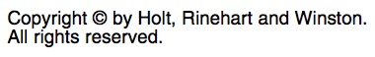
Day 17

Calculating Odds

Objective: Students will be able to calculate the odds of an event occurring in different situations.

Launch: Review how to calculate the probability of events occurring (independent, dependent, etc.). Then, bring the discussion around to the guiding question, “What does it mean when you say the odds of winning are good or bad?” Discuss the difference between calculating the probability of an event occurring and calculating the odds of an event occurring. Giving students some notes may be appropriate here, and it would be a good chance to review notation, fractions, and percentages. Compare and contrast probability and odds. This lesson can also be used as a review or introduction of regular polyhedrons.

Explore: Students should be given the handout on the following page. Having students work in groups would recommended for this activity.

Share: Have groups report their findings to the entire class. This could be done by having students come to the board to explain one row of the table. Bring the discussion back to differences and similarities of calculating the probability of an event and calculating the odds of an event.

Summarize: Have students write 3 – 5 sentences comparing and contrasting the ‘probability’ of an event occurring and the ‘odds’ of an event occurring. Bring this back to the guiding question listed above.

Calculating Odds

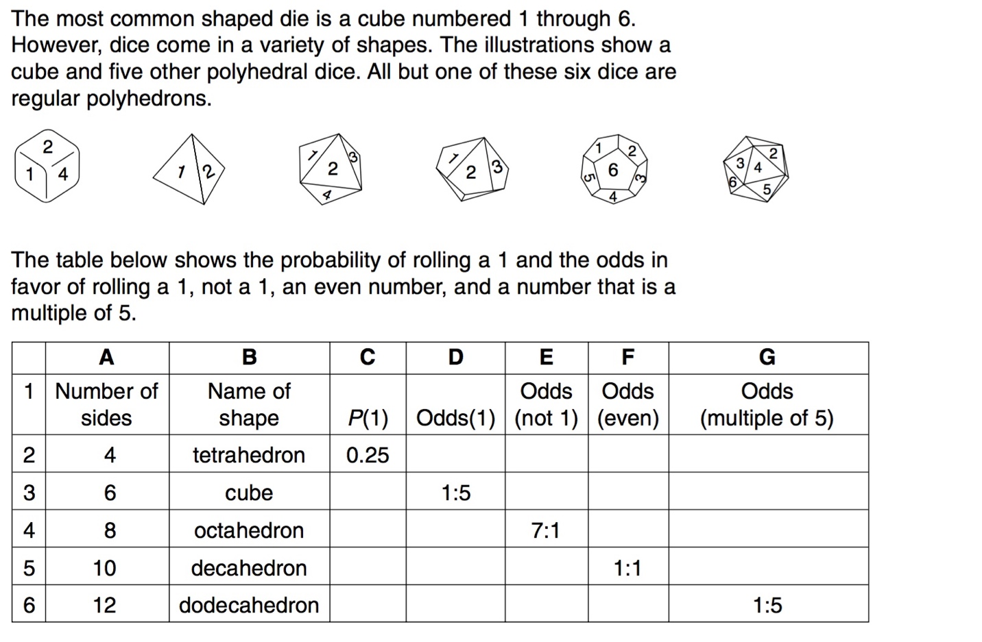
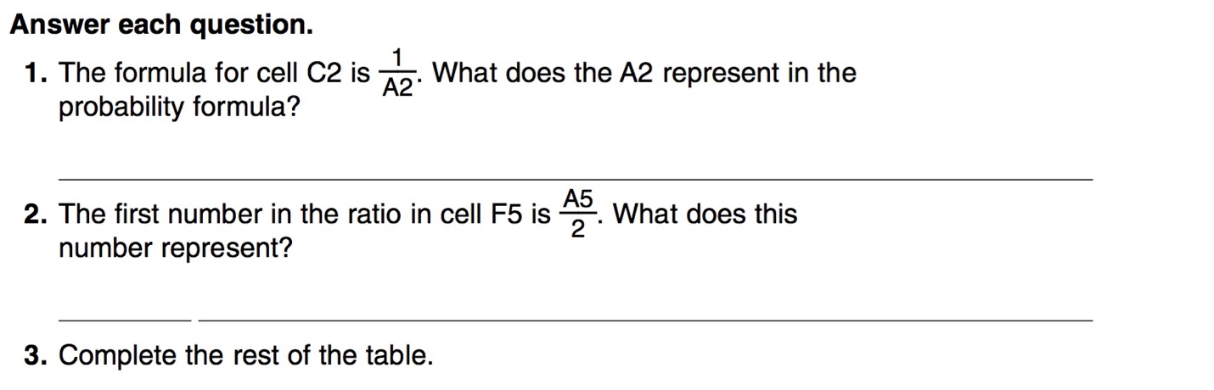

10,000

Probability Unit Pretest Name:_________________
1) If the probability of winning a game is 25% find the following:
a) The P(winning) after winning 6 games in a row.

b) Which is more likely, winning 9 out of 10 games or 18 out of 20 games? Explain.

2) Imagine a game where you flip a coin 3 times in a row.
a) Make a sample space representing this game.

b) Use your sample space to find P(2 heads and 1 tail)

3) In a raffle 1 person can win $100 and two other people will win $20. If 70 tickets were sold, what is the expected value of a ticket?

4) If you have 3 pairs of pants, 5 shirts, and 2 different pairs of shoes to choose from. How many different outfits can be made from one of each clothing item?

5) If the probability that you arrive on time is $\frac{3}{8}$ what are the odds that you are late?

Probability Unit Post Test Name:_________________
1) If the probability of winning a game is 90% find the following:
a) The P(winning) after winning 6 games in a row.

b) Which is more likely, winning 2 out of 10 games or 4 out of 20 games? Explain.

2) Imagine a game where you flip a coin 4 times in a row.
a) Make a sample space representing this game.

b) Use your sample space to find P(2 heads and 2 tails)

3) In a raffle 1 person can win $100 and two other people will win $50. If 400 tickets were sold, what is the expected value of a ticket?

4) Parking passes consist of two letters followed by two numbers.
a) How many different passes are possible if repeated characters are not allowed?

b) How many different passes are possible if repeated characters are allowed?

5) If the odds of winning a game are 5 to 1, what is the probability of winning?

